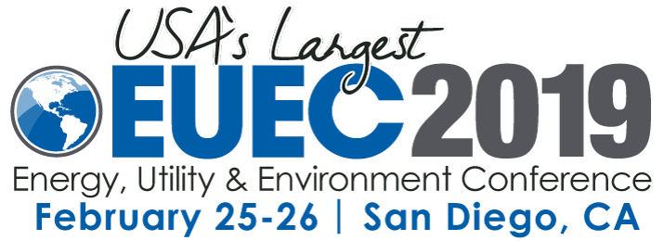

INSERT NAME of ORGANIZATION to Speak at 22nd Annual Energy, Utility & Environment Conference (EUEC)

Held February 25–27, 2019, at the San Diego Convention Center, EUEC is co-located with the Transportation Electrification Expo (TE-Expo)

SAN DIEGO, DATE — INSERT NAME, TITLE, of INSERT ORGANIZATION will speak at the 22nd Annual Energy, Utility & Environment Conference (EUEC) being held February 25–27, 2019, at the San Diego Convention Center. Entitled, “INSERT TITLE,” his/her presentation will focus on INSERT TOPIC DESCRIPTION. His/her presentation will take place on INSERT DATE, TIME at PLACE.

“We are pleased to welcome INSERT NAME to share his/her energy industry extensive knowledge at this year’s EUEC,” said Dr. Prabhu Dayal, Chairman, EUEC. “EUEC features top-tier speakers and exhibits from companies who are leading the charge in alternative energy.”

“QUOTE,” from speaker, title, company.

INCLUDE SPEAKER BIO AND ANY ADDITIONAL PRESENTATION DETAILS ON HERE

This year’s EUEC keynotes include representatives from the Environmental Protection Agency, San Diego Gas & Electric and the California Air Resource Board.

The EUEC show floor features more than 200 exhibitors, giving attendees access to companies and organizations that are involved in utility fleets and battery and charging technologies as well electric and alternative fuel vehicle manufacturers. EUEC is co-located with the Transportation Electrification Expo (TE-Expo).

For the complete listing of EUEC and TE-Expo speakers and exhibitors, click here.

VIP DISCOUNTS: For EUEC VIP discounted conference pricing, click here. Go to VIP Registration and use INSERT COMPANY NAME as the discount code to get the $495 EUEC admission price (a discount of $500 from the $995 standard advance admission price).

INSERT ORGANIZATION BOILER PLATE

About EUEC2019

EUEC2019 is the 22nd Annual Energy, Utility & Environment Conference, the largest professional education, training and networking event of its kind held in the United States. More than 400 expert speakers will make presentations on current alternative energy technologies, strategies and regulations that impact operations, management and compliance of electric utilities. For more information, visit www.EUEC.com
PR Contact:
Teri Sawyer, T&Co.
714-801-1687
TeriSawyer@me.com

